A Program to Study Pollution-Meteorology Feedbacks in Southeast Asia:
The Seven SouthEast Asian Studies (7 SEAS) Mission

Draft: March 4, 2009

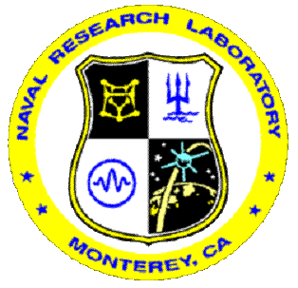

Executive Summary:
Over the last several decades the region extending from Java though the Malay Peninsula and Southeast Asia to Taiwan has seen massive economic growth. Consequently, air pollution levels have increased dramatically. At the same time, biomass burning has become an ever-increasing problem, further reducing human and visual air quality. Even so, at times this region exhibits some of the lowest concentrations of lower troposphere aerosol particles in the world. These sharp gradients present an excellent natural laboratory for studying aerosol-meteorology feedbacks in tropical to sub-tropical environments. While extremely interesting and complicated atmospheric phenomena occur throughout Southeast Asia, the scientific community is only beginning to recognize this region’s importance to global climate change and Earth System Science as a whole. Considerable basic research and outreach are required to develop adequate environmental observing systems to cope with the needs of this important region
Through collaboration with currently active Southeast Asia regional science partners (Malaysia, Philippines, Singapore, Taiwan, Thailand and Vietnam), NASA’s Radiation Science, Tropospheric Chemistry, Air Quality, and Oceanography programs, as well as the Office of Naval Research (ONR), Office of Naval Research-Global (ONRG), and the US State Department, an opportunity exists for mounting an international atmospheric sciences project encompassing much of Southeast Asia. The proposed 7 SouthEast Asian Studies, (7 SEAS), will be a comprehensive interdisciplinary atmospheric sciences program to study the interactions of pollution with regional meteorology, particularly with clouds. Not only is there interest in how changes in atmospheric composition impact meteorology through radiative and microphysical processes, but also in how these impacts can feed back into boundary layer pollution emissions, concentrations, evolution, scavenging and transport. These feedbacks also cause interactions of interest to a wide variety of other Earth systems science fields such as oceanography and land surface science.

With in-situ, remote sensing and modeling components available, 7SEAS intends to further enhance collaboration between in-region scientists and develop a wide-ranging SouthEast Asian scientific data network. It is hoped that 7SEAS will peak with a major field campaign performed in conjunction with a number of other regional research programs in the 2011-2012 time frame. The legacy of 7SEAS will be a better understanding of the SE Asian pollution environment: aiding regional scientists and policy makers as well as advancing the next generation of environmental observing and prediction systems.

Rationale and Scientific Basis
Even under the best of circumstances, the land-ocean and atmospheric system is complex and difficult to monitor. As a consequence, the study of any one particular aspect of the Earth system in isolation is problematic: every component is dependent on many others. But, on rare occasions, environmental conditions exist that allow us to examine individual components orthogonally; that is, when only one parameter changes while the others remain static. In the Southeast Asian region, we see these orthogonal conditions; it is one place where we can isolate the effects of aerosol particles on clouds and precipitation, and their subsequent feedbacks into the air, ocean, and land system. In particular, while meteorological cloud forcing should be similar over Java to the Malay Peninsula and over the stratus regions off the coast of Vietnam, in this region, strong aerosol loadings from biomass burning and industry exist only a few hundred kilometers downwind of areas in which the atmosphere can be considered pristine. Additionally, depending on aerosol transport patterns, the numerous islands in the region can allow us to study pristine oceanic and over-land conditions. These unique environments provide an opportunity for researchers to isolate the feedbacks between pollution and the atmosphere’s heat budget, clouds, and other meteorological properties. We can conceptualize the interaction of pollution and atmospheric process on three broad scales:
Figure 1. Measured cloud base cloud droplet size distributions in different environments over Indonesia. Courtesy of Roelof Bruintjes, NCAR.
  - Microphysics/cloud based scales such as the first (cloud reflectivity) and second (precipitation) indirect effects.
  - Mesoscale radiation and heat budget perturbations, including semi-direct effect, atmospheric diabatic heating/stabilization and perturbations to the sensible and latent heat flux.
  - Large scale direct forcing on large scale atmospheric/ocean phenomenon such as the migration of the InterTropical Convergence Zone (ITCZ), El Nino/Southern Oscillation (ENSO), and longwave patterns.

As an example of microphysics effects, consider previous measurements of cloud base cloud droplet size distributions over different parts of Indonesia as a function of regional aerosol loading (Figure 1). Total droplet concentrations and size distributions vary widely, impacting both radiative characteristics and precipitation processes in clouds. It is interesting to note the differences between the continental clean and maritime clean clouds: the droplet concentration is approximately the same, but the size distributions are markedly different. These different clouds have markedly different impacts in the environment, with cleaner clouds precipitating and showing less vertical development, thus feeding back into the wet deposition and boundary layer ventilation problem. It has been hypothesized that these types of microphysical impacts can influence much larger cloud and precipitation processes. While these findings are consistent with known theory and other observations, difficulties arise when we try and apply this knowledge in any quantitative way. For example, are the differences in the pristine over-water and over-land size spectrum due to sea-salt particles being the CCN 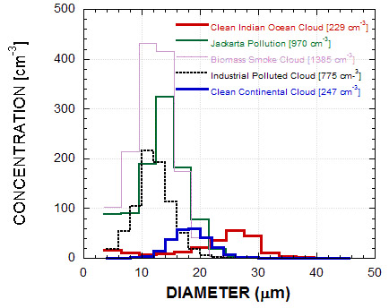in the maritime case and potentially biogenic nuclei being CCN in the continental clean cloud? Are they related to the differences in size between these nuclei?
Figure 1. Measured cloud base cloud droplet size distributions in different environments over Indonesia. Courtesy of Roelof Bruintjes, NCAR.
These microphysical effects can also co-vary with meso-scale impacts related to the surface heat budget, heating, and convergence/divergence associated with convective pumping to the free troposphere. Complicating the situation is the nature of coastal environments. Does the over-land boundary layer structure and heat flux result in clouds with different updrafts than their over-water developed counterparts? Is our perceived observation of aerosol-cloud interaction confounded by regional anthropogenic land surface changes which occur in emissions regions? Are there feedbacks in coastal waters from complicated littoral meteorology? A simple example of this is given in Figure 2, which presents a MODIS RGB image of a thick smoke plume on the island of Borneo. In the thickest part of the smoke plume (center) the fair weather cumulus clouds which are so prevalent in the cleaner portion of the scene (bottom left) are absent; most likely due to the smoke’s radiative impact on the atmosphere. In the outer smoke plume (upper left), clouds are present, but note the difference: fewer numbers of larger clouds. The questions facing scientists from this image include how much smoke is required to impact the development of clouds of any given size? How much of this variability is natural (since cloud properties change as the surface type changes as well)? Like the microphysical question, these impacts feed back into the question of precipitation scavenging, mesoscale winds, and the ventilation of boundary layer air into the free troposphere.

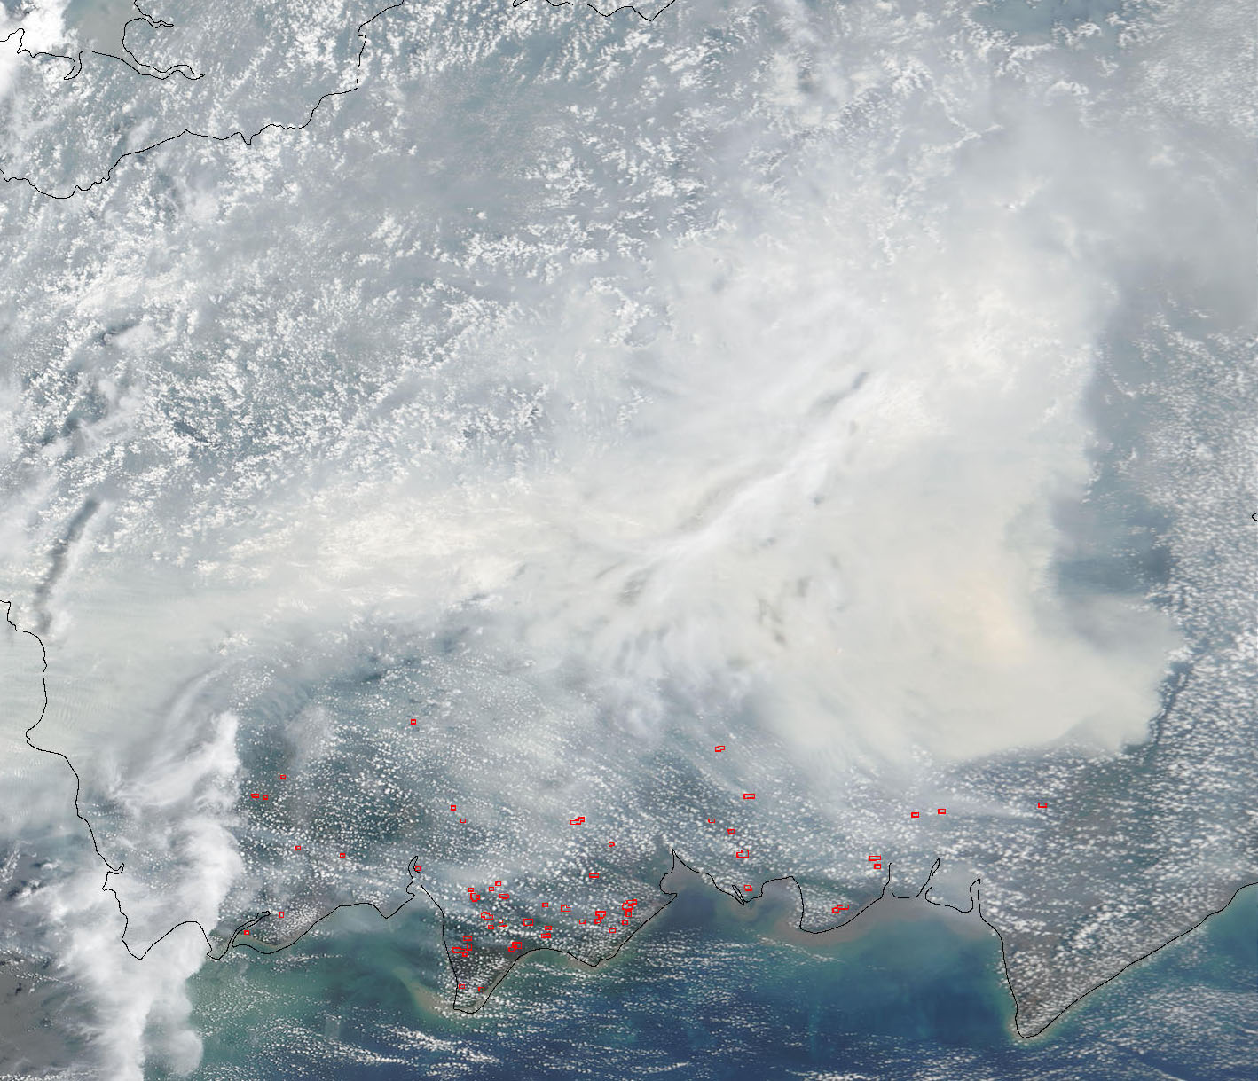
Clean
Heavy Smoke
Moderate Smoke
Land Surface Change
Figure 2. A RGB NASA MODIS image of biomass burning smoke on the island of Borneo. Compare cloud textural feathers between the clean (lower right), thick smoke (center) and outer smoke (upper left). Also note the change in cloud patters from cleared to forest surface types at the center right.
At the largest meteorological scales, we have a fundamental cause and effect problem. Years of significant drought, such as those associated with the warm phase of El Nino/Southern Oscillation (ENSO), are associated with increase burning and large scale smoke coverage. There is considerable scientific effort in the community to determine if increased smoke loadings can prolong drought conditions, thus increasing smoke coverage. But, most of the regional precipitation is associated with the migration of the Inter-Tropical Convergence Zone (ITCZ). The ITCZ’s latitudinal migration is typically very rapid (Figure 3) and may be associated with a large scale radiation tipping point. A key question then is, to what extent can large scale radiation perturbations impact the onset of migration?
A thorough understanding of the issues above, as well as the Southeast Asian atmosphere in general, requires attention to a number of scientific and technological obstacles. Most importantly, the prevalent cloud conditions and significant convective rainfall, both of which we want to study, make remote sensing and modeling in the region difficult. Shallow waters, numerous islands and ambiguous wave fields further hinder the parameterization of lower boundary conditions. Many of the meteorological processes that we wish to study co-vary with poor observing conditions. And since the current satellite and surface observing system is incomplete and untested, the long term 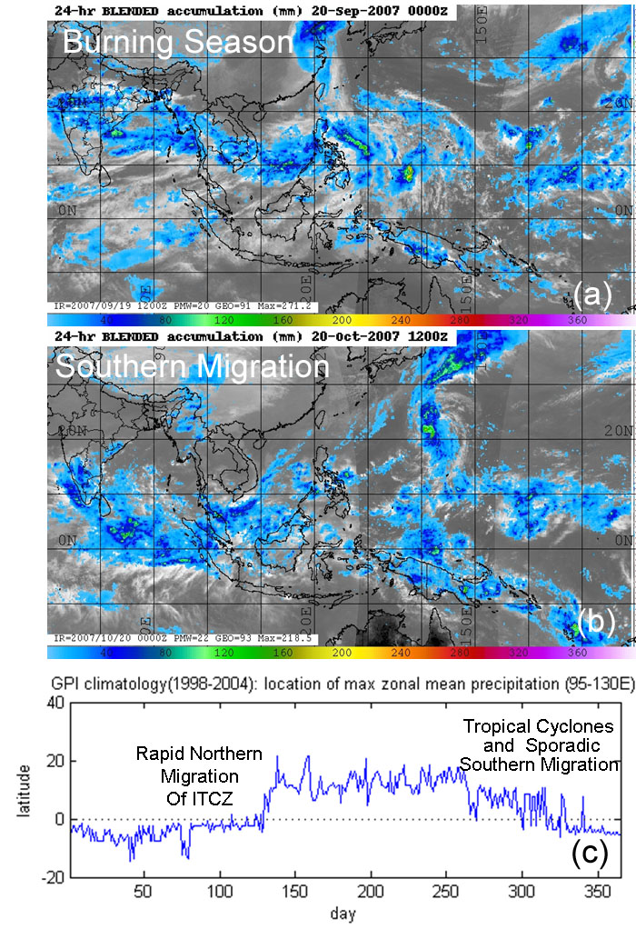monitoring of variables needed to assess pollution and meteorology relationships is not currently available. Consequently, observation enhancement and product calibration/validation must be an integral part of any scientific study.
Figure 3. 24 hour blended TRMM/SSMI/Geostationary precipitation product just before (a) and after (b) the southward migration of the ITCZ into the SE Asian burning region for 2007 (Courtesy Joseph Turk, NRL). (c), Location of the average SE Asian maximum precipitation feature from GPI (Courtesy Peng Xian, NRL)
An example of the differences in pollution related satellite product efficacy is presented in Figure 4, where we present the 2004 annual average aerosol optical depth data derived from the MODerate resolution Imaging Spectroradiometer (MODIS) and the Multiangle Imaging SpectroRadiometer (MISR) on the Terra spacecraft. Qualitatively, the products are similar. On the windward side of Southeast Asia the atmosphere is extremely clean. Downwind of populated areas and regions of prevalent biomass burning, aerosol optical depths are much higher. However, significant quantitative differences exist, especially in coastal areas. A number of possible factors, including inadequate cloud screening, uncertainties in the lower boundary conditions, and ambiguity in the appropriate aerosol radiative models may be responsible for these results. Similar statements can be made with regards to the detection of biomass burning. Regardless, the current uncertainties the data from available monitoring systems make application of their data semi-quantitative at best.

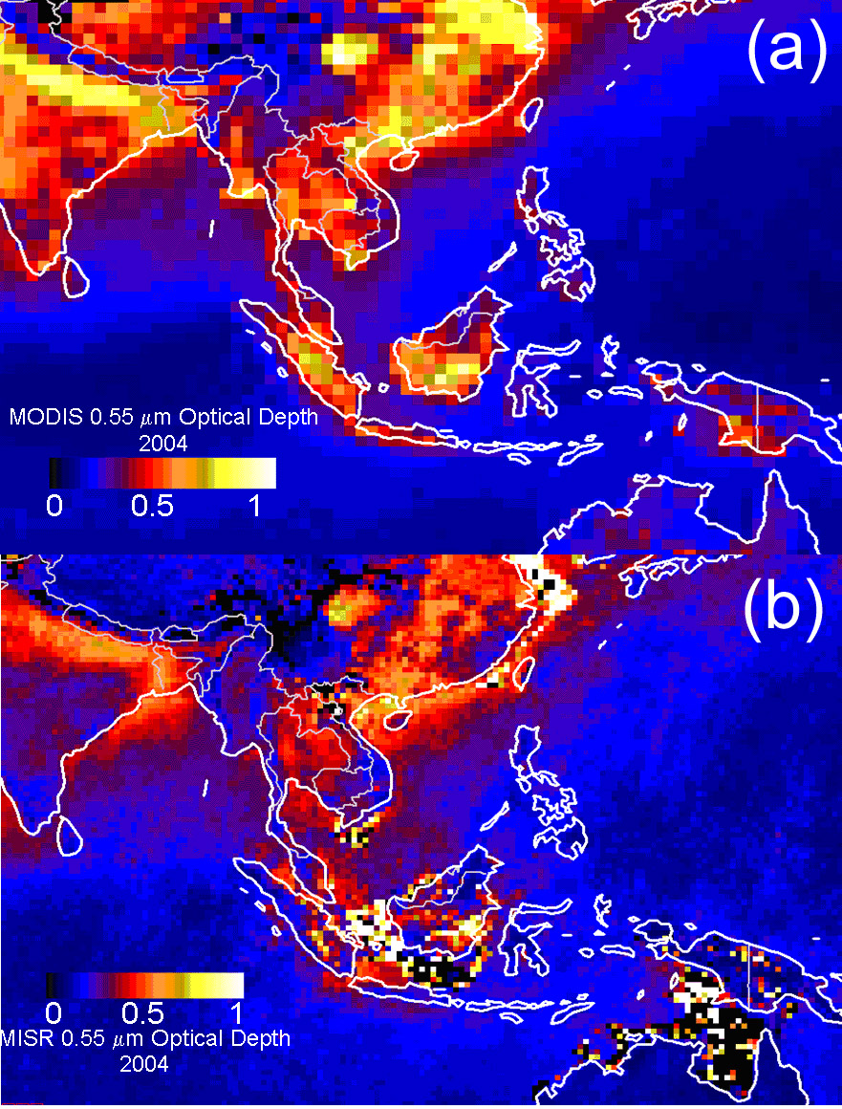
Figure 4. 2004 MODIS (Upper) and MISR (Lower) annual average aerosol optical thickness. While both systems qualitatively agree on significant aerosol loading regions, quantitatively they are quite different.

The above difficulties can confound our analysis with perceived “chicken and egg” scenarios. Consider Figure 5, where we present biomass burning coverage maps derived from MODIS fire hot spot detections. Often regional burning activity is so persistent, with fires overlapping one another, that it is difficult to even plot. But, significant internal differences still exist. From a precipitation point of view, does burning activity suppress rainfall, which would in turn lead to more burning? Or, do we perceive more burning during cloud-free/low precipitation periods simply because the satellite can observe the surface more frequently? In general we know that drought years correspond to more burning, but these feedback mechanisms quickly become complicated, hindering our ability to separate cause and effect, and to ultimately interpret what is happening on a regional basis.
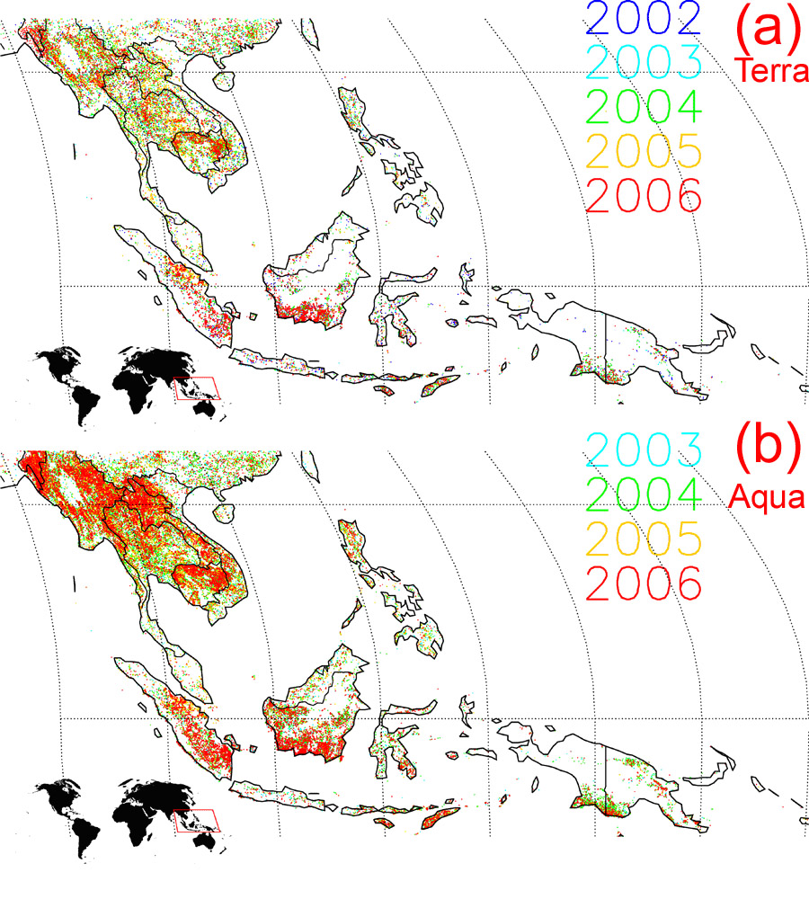
Figure 5. Fire hotspot detections from MODIS on (a) Terra and (b) Aqua.

Seven scientific areas of interest that form 7SEAS
Because of the relationship between scientific needs and improved remote observations 7SEAS addresses both fundamental scientific and engineering problems. Key science questions for 7SEAS focus on the examination of aerosol impacts on cloud systems through radiative perturbation of the land surface, ocean and air surrounding clouds. The chain of scientific questions can be interpreted as five specific science requirements:

- Examination of microphysical, mesoscale and long-wave relationships in the surface, aerosol, and cloud system.

- Establish the vertical distribution and direct impact of atmospheric light absorption and diabatic heating on small to mid-size cumulous.

- Evaluate the impact of perturbed radiation fields from aerosol particles on land and ocean sensible and latent heat flux, with consequent impact on clouds and precipitation.

- Assess the degree of feedback of surface irradiance on ocean photochemistry and, consequently, on ocean albedo and heat fluxes.

- Determine how aerosol-meteorology impacts feed back into boundary layer aerosol concentrations, though source perturbation, transport, convective ventilation, and scavenging.

To address the above topic areas and develop a true picture of aerosol-meteorology relationships, there are a number of scientific disciplines which require attention. In particular, there are 7 broad based study topics which feed into the 7-SEAS program. These are:

1) Clouds and Precipitation: Air masses vary from the extremely clean to the very polluted. For example, NCAR recently made observations of significant precipitation forming in clouds with only a few hundred meters vertical development, which is only possible in the cleanest of conditions. Conversely, in our SouthEast Asia study region, thick plumes of city pollution and biomass burning are frequently entrained in both convective systems to the south, and stratus clouds in the north. Gradients are expected to be strong. Clouds strongly influence pollution concentrations in the boundary layer through wet deposition (i.e., removal) as well as convective pumping (e.g., ventilation). This topic is the cornerstone for the mission, to which all other topics will relate.

2) Radiative transfer: Radiative transfer studies have mostly been performed in the mid-latitudes and subtropics, partly because the tropical environment poses special challenges. The combination of pollution, smoke and sea salt creates a complicated environment that is difficult to model and monitor. In particular, aerosol particles may cool or heat the atmosphere, perturbing the atmospheric heat budget and impacting cloud formation and growth. Similarly, towering clouds can reflect light into clear areas, thus perturbing the direct/diffuse partition. Just as aerosol particles can impact precipitation processes, they can also impact cloud reflectivity and lifetime.

3) Anthropogenic and biomass burning emissions and evolution: In order to understand pollution-meteorology interaction we must know a great deal about the pollution emissions as well as how pollution evolves in the atmosphere. Severe biomass burning episodes are frequently reported throughout Southeast Asia. Often as a result of deforestation burning or agricultural burning gone out of control, smoke blankets the entire region at times, reducing visibility to only a few kilometers. During periods of El Nino, burning events are often the most severe. In 1998, burning was so extensive that cities were on hazardous air quality alerts for months. The crash of a Boeing 737 and several collisions of merchant ships were in part due to very poor visibility conditions. While significant on even the global climate level, biomass-burning in Southeast Asia has only been studied sporadically. These studies have suggested that chemical and microphysical properties of smoke are different from other parts of the world. For example, peat fires may in fact be the dominant producer of smoke. More soluble species are found, suggesting that particle hygroscopic growth is likely to be higher. The reasons for this are unclear, but could be due to differences in the fuel and fuel emissions, or in the smoke evolutionary process under the high humidity and intense solar radiation of the tropics. Another possibility is that these results are biased by the presence of regional pollution. Atmospheric pollution emissions in Asia are highly variable and often form dense plumes emanating from cities. Because the economies are so varied, particle chemistry varies significantly by region; from common industrial sulfates to organic-rich biofuels emissions. Intense solar radiation likely creates a thick photochemical soup. As the chemical properties of these emissions change, so does their potential for cloud and radiation impacts.

4) Natural background atmospheric chemistry: We need a fundamental understanding of the natural background environment before we can assess anthropogenic impact. Despite the high pollution and smoke loadings in the region, Southeast Asia can also display extremely clean conditions. Some studies in such clean environments suggest that homogenous nucleation is not common. Hence, this region is an excellent location to study one extreme of the “background” aerosol problem. Sea salt and biogenic emissions have never been studied here.

5) Tropical-subtropical meteorology: Tying together all of the above research topics is the role of fundamental regional meteorology. The 7SEAS study area is rich with islands and warm waters, making the mesoscale and microscale meteorology complicated. Boundary layer properties vary, as do the sensible and latent heat fluxes. Regional winds are difficult to predict, making transport modeling problematic. Like background chemistry, we need an understanding of natural meteorological process before we can assess anthropogenic impacts at the micro, meso and large scales.

6) Regional nowcasting, forecasting, and inter-annual/climate outlooks: Mission goals are not strictly physical meteorology related; it is expected that all work will have an operational, transition or other societal and educational benefits. These include satellite and surface data assimilation, storm nowcasting and forecasting, as well as inter-seasonal forecasting and outlook development. Climate change is a serious issue for the region, and knowledge generated from 7SEAS needs to be applicable to tangible climate change problems.

7) Calibration/validation: Lastly, the variations in aerosol speciation (smoke, biogenic aerosols, agricultural burning (rice field), industrial and city pollution, sea salt, etc.), coupled with variability in ocean color, land use, and clouds and precipitation, makes Southeast Asia an excellent region for the calibration/validation of a host of remote sensing and modeling systems. In particular, this region is suited for the refinement of aerosol/cloud interaction relevant products. For example, at the time of this study, CloudSat, CALIPSO, GLORY and NPP should be in full operation, completing the A-train system. Also, geostationary fire products will be generated quasi-operationally, and the next generation of air quality models can be tested. These datasets will form the basis for the study of long-term trends, and allow extrapolation of the findings of the field mission.

Progress and Plan of Action:

From an observational point of view, to meet the science requirements of 7-SEAS, we have five primary observing requirements:

- Diagnose the ability to measure light absorption and diabatic heating rates in the atmosphere.

- Investigate the ability to estimate surface radiative fluxes based on remote sensing data.

- Generate a dataset for development and validation of joint ocean/atmosphere retrieval algorithms and process-orientated modeling of meteorology and aerosol interactions in complicated environments.

- Observe seasonal and regional trends in aerosol concentrations through a mixture of consistent surface and remote sensing data sets.

- Support calibration and validation efforts of current and future remote sensing sensors, such as MODIS, MISR, Glory, CALIPSO and VIIRS.

These requirements require the development of an international science team for the establishment of consistent ground networks and targeted intensive operations periods (IOPs). The success of this mission is highly dependant on the cooperation and collaboration of the host counties. But in general, the mission will be guided by the following progression:

- Phase 1: Promote interactions between 7-SEAS scientists. Exchange ideas and community data; Devise a plan for future collaborative research.

- Phase 2: Develop a surface instrumentation network and data distribution system. Devise regionally suited satellite and model datasets. Encourage scientist interaction and on-site exchange. Begin development of an Indonesian research aircraft platform.

- Phase 3: Perform intensive operations period (IOP) missions.

- No set timeline, progress when all stakeholders are ready.
Phase 1.
Phase 1 has been completed through two science workshops. The first regional planning meeting was hosted by BPPT (the Indonesian Science and Technology Development Agency) the week of May 14th, 2007 in Jakarta, Indonesia to decide further action. Action items from this meeting included the formation of an Executive Committee, the establishment of a data portal (http://www.nrlmry.navy.mil/flambe/7seas/7seas.html), and a period of special data archives for a Virtual Biomass Burning Experiment (VBBE) covering SE Asia for the month of August 2007. Since then, the main 7-SEAS site has also been established and is currently under construction: (http://7-seas.gsfc.nasa.gov )
The second regional meeting the week of January 14th 2008 at National Central University, Taiwan discussed preliminary results from VBBE and developed plans for the future and the layout of phase 2. Since the second meeting, scientists have been updating individual science plans and working to garner support from their host countries. Data agreements are under review, and additional network instruments are beginning to be placed in region, including several AERONET sun photometers and a micropulse lidar. Small field campaigns for preliminary data collection and hypotheses development are underway.
Also in 2009, to increase interaction between 7SEAS scientists, we initiated a program of regional remote sensing training. This has both basic research and applied science aspects. Early week-long training sessions will focus on advanced graduate students and researchers. However, this focus will transition to training regional partners at the introductory level as the program progresses.

Phase 2.
Phase 2 is currently underway, with the expansion of Aerosol Robotic Network sun photometer sites (AERONET). It is the intention of the 7SEAS community to use these sites as the anchor for long term monitoring. AERONET already has a presence in Thailand, Vietnam, Taiwan and Singapore. 7SEAS is actively expanding in the Philippines. Negotiations for expansion in Malaysia and Indonesia are underway.
A map of current and planned 7SEAS surface sites is presented in Figure 6. In 2009, we expect a significant increase in the number of AERONET sites in region. Central to this expansion will be the development of regional supersites. The 3000 m Lulin Station, a Taiwan EPA-funded atmospheric chemistry monitoring station has been in operation for 2 years and has collected data that is highly relevant to the 7SEAS mission. Two additional supersites are currently under development; a supersite at National University of Singapore, and the Taiwanese Dongsha (or Pratas) Island site. A cornerstone instrument for these sites will be micropulse lidars in the NASA MicroPulse Lidar Network (MPLNet). MPLNet instruments will be installed at two or three of these sites. Further instrumentation enhancements are currently being investigated for Malaysia and the Philippines. The 7SEAS community is actively searching for partners in Indonesia.
By 2010 we plan to have all network instruments in place, and begin construction on remaining super sites. We are currently looking for ride-along opportunities on UNOLS research vessel cruises in the region to supplement the ground station data. Ride-along opportunities on Taiwanese research vessels currently appear promising.

Phase 3.
The 7SEAS community is currently planning Intensive Operations Periods (IOPs) in the March-April and September-October time periods to capture the Peninsular and Insular Southeast Asian burning seasons, respectively. These periods will include increased sampling at the surface sites, and will likely include deployment of NRL’s Mobile Atmospheric Aerosol and Radiation and Characterization Observatory (MAARCO); and the NASA/GSFC Surface-sensing Measurements for Atmospheric Radiative Transfer and the Chemical, Optical & Microphysical Measurements of In-situ Troposphere mobile measurement facilities (SMART COMMIT). Currently we are searching for extended cruise opportunities, in particular on Taiwanese research vessels. All 7-SEAS participants are welcome to deploy their instruments on the islands and research vessels, and to perform observations at their own sites. Data will be shared for all participants.
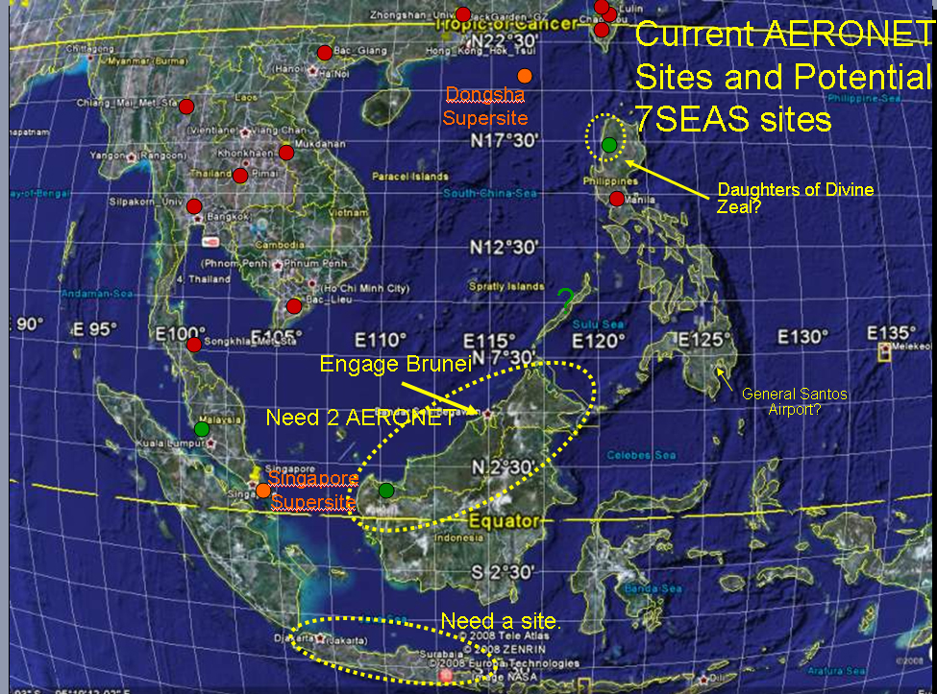
In the 2011 or 2012 timeframe, 7SEAS will be a contributor to a large NASA regional field effort in SE Asia; the Pacific Atmospheric Composition, Cloud, and Climate Experiment (PAC³E). This effort has comprehensive atmospheric chemistry and radiation components, but with a primary focus on the role of convection in pumping and evolving boundary layer air into the free troposphere. Whereas 7SEAS is a multi-year regional effort, PAC³E will be a focal intensive operations period across multiple NASA programs.
Figure 6. Current and proposed surface sites in the Southeast Asian region.
PAC³E is a 2011 field deployment and intensive operations period in support of 3 atmospheric composition focus areas: Radiation Sciences Program (RSP), Tropospheric Chemistry Program (TCP), and Upper Atmosphere Research Program (UARP). In addition, several other NASA programs are currently expected to contribute, including the Applied Science Air Quality Program (ASPAQ), and the Biological Oceanography Program (BOP). While highly interdisciplinary in nature, PAC³E’s binding theme is the transport and vertical redistribution of atmospheric constituents by and in proximity to convection. These physical mechanisms feed key disciplinary science questions such as: Mid-troposphere injection and photochemical evolution of boundary layer constituents by convective cells (e.g., TCP); upper troposphere and lower stratosphere injection of trace gasses by deep convection and cirrus (UARP); and ventilation of boundary layer constituents by convection (ASPAQ).
It is proposed that PAC³E support the development of an interdisciplinary community derived from the traditional fields of atmospheric radiation, land surface change, and biological oceanography. Currently the multi-year international and interdisciplinary 7 Southeast Asian Studies (7SEAS) program is under development to study the radiative balance and feedbacks from the surface, aerosol, and cloud systems. It is expected that PAC³E data will provide valuable Earth system and climate science information to 7SEAS and other such programs. Simultaneously, the radiation community is attempting to define key science questions and measurement parameters for sensors on the Aerosol, Cloud, Ecosystems (ACE) and Geostationary Coastal and Air Pollution Events (GEO-CAPE) satellites. PAC³E will be an excellent venue for preparatory research and algorithm development for the ACE and other decadal survey missions.
PAC³E is tentatively scheduled to be performed out of a Southeast Asian country; Thailand and Brunei are both currently under consideration. It is anticipated that the PAC³E mission will utilize the NASA DC-8 and ER-2 aircraft. It is hoped that sufficient support will be available for a third aircraft, such as the WB-57 or NCAR Hyper. Additional surface and shipboard measurements will be supported by the congruent 7SEAS research program. By its interdisciplinary nature, payloads will be limited and it is expected that some compromise will be required by all participants.
In 2012 and beyond, 7SEAS will evaluate PAC³E data and finally focus on new instrumentation and modeling systems for the continued evaluation of the SE Asian system.

7 SEAS Directory

Interested parties should contact their country representatives listed with an “*” here. For questions regarding this document, please contact Jeffrey S. Reid, Naval Research Laboratory, 1 9831) 656-4725; jeffrey.reid@nrlmry.navy.mil

Malaysia:
Mastura Mahmud*
Associate Professor
Universiti Kebangsaan Malaysia
Department of Geography
46300 Bangi
Selangor, Malaysia
Tel. +60 (3) 829-2672; Fax. +60 (3) 829-3334
E-mail: mastura@pkrisc.cc.ukm.my; mastura.mahamod@gmail.com

Maznorizan Mohamad
Malaysian Meteorology Service
Email: maz@met.gov.my

Wan Azli Wan Hassan
Malaysian Meteorology Service
Email: wanazli@met.gov.my

Philippines:
Nofel Lagrosas*
Manila Observatory
Ateneo de Manila University Campus
Loyola Heights, Katipunan Avenue
1108 Quezon City, Philippines
E-mail: nofel@observatory.ph

Melvin Purzuelo
Green Forum- Western Visayas
E-mail : rebohan@yahoo.com

James Bernard Simpas
Manila Observatory
Ateneo de Manila University Campus
Loyola Heights, Katipunan Avenue
1108 Quezon City, , Philippines

Singapore
Chew Boon Ning*
Research Associate
Centre for Remote Imaging, Sensing and Processing (CRISP)
National University of Singapore
Blk SOC-1/CRISP Level 2, Lower Kent Ridge Road
Singapore 119260
E-mail: crscbn@nus.edu.sg

Liew Soo Chin*
Head of Research
Centre for Remote Imaging, Sensing and Processing (CRISP)
National University of Singapore
Blk SOC-1/CRISP Level 2, Lower Kent Ridge Road
Singapore 119260
Tel. +65 65165069; Fax. +65 67757717
E-mail: crslsc@nus.edu.sg

Rajasekhar Bala*
Associate Professor
Division of Environmental Science & Engineering
National University of Singapore
Email: eserbala@nus.edu.sg

Santo Salinas
Research Associate
Centre for Remote Imaging, Sensing and Processing (CRISP)
National University of Singapore
Blk SOC-1/CRISP Level 2, Lower Kent Ridge Road
Singapore 119260
Email: crsscsv@nus.edu.sg

Taiwan
Neng-Huei (George) Lin*
Professor
Department of Atmospheric Sciences
National Central University
Chung-Li 320, Taiwan
Tel. & Fax: +886 (3) 4254069
E-mail: nhlin@cc.ncu.edu.tw

Thailand
Serm Janjai*
Associate Professor
Dept. of Physics
Silpakorn University
Nakhon Pathom, Thailand
Tel. +66 (34) 270761, 271189; Fax : +66 (34) 271189;
E- mail: serm@su.ac.th

Vietnam
Anh Xuan Nguyen
Professor
Dept. Atmospheric Physics
Institute of Geophysics
Vietnam Academy of Science and Technology
18, Hoang Quoc Viet, Cau Giay, Hanoi, Vietnam
Tel. +84 (4)-7562801; Fax: +84 (4)-8364696;
E-mail: nxuananh@yahoo.com;
Web: http://www.thunderstorm.org.vn/

United States:
National Aeronautics and Space Administration (NASA):
David Giles*
Code 614.4
NASA Goddard Space Flight Center
Greenbelt, MD 20771
Email: David.M.Giles@nasa.gov
Web: http://aeronet.gsfc.nasa.gov/

Brent Holben*
Code 614.4
NASA Goddard Space Flight Center
Greenbelt, MD 20771
Tel. +1 (301) 614-6658; Fax. +1 (301) 614-6695
Email: brent@aeronet.gsfc.nasa.gov
Web: http://aeronet.gsfc.nasa.gov/

Christina Hsu
NASA Goddard Space Flight Center
Code 613
Greenbelt, MD 20771
Tel. +1 (301) 614-5554
Email: Christina.Hsu@nasa.gov

Hal B. Maring
NASA Headquarters
Radiation Sciences Program
Science Mission Directorate
Mail Suite 5H79
NASA Headquarters
Washington, DC 20546-0001
Tel. +1 (202) 358-1679; Fax. +1 (202) 358-2770
Email: hal.maring@nasa.gov

Si-Chee Tsay
NASA Goddard Space Flight Center
Code 613.2
Greenbelt, MD 20771
Tel. +1 (301) 614-6188; Fax. +1 (301) 614-6307
Email: tsay@aeronet.gsfc.nasa.gov
Web: http://smart-commit.gsfc.nasa.gov/

E. Judd Welton
NASA Goddard Space Flight Center
Code 613.1
Greenbelt, MD 20771 USA
Tel. +1 (301) 614-6279; Fax: 301-614-5492
Email: Ellsworth.J.Welton@nasa.
Web: http://mplnet.gsfc.nasa.gov

Naval Research Laboratory (NRL):
Edward J. Hyer
UCAR Project Scientist, Marine Meteorology Division, NRL
7 Grace Hopper St., Stop 2
Monterey, CA 93943
Tel. +1 (831) 656-4725; Fax. +1 (831) 656-4769
Email: Edward.hyer@nrlmry.navy.mil
Web: http://www.nrlmry.navy.mil/flambe/

Jeffrey S. Reid*
Marine Meteorology Division, NRL
7 Grace Hopper St., Stop 2
Monterey, CA 93943
Tel. +1 (831) 656-4725; Fax. +1 (831) 656-4769
Email: jeffrey.reid@nrlmry.navy.mil
Web: http://www.nrlmry.navy.mil/flambe/7seas/7seas.html

Office of Naval Research Global (ONR):
Joseph Johnson*
ONR Global – Asia
US Embassy Singapore
Tel. +65 6476-9146
Email: joseph.johnson@onrasia.navy.mil
Web: http://www.onrglobal.navy.mil/

State Department
William Behn*
Regional and Security Policy Affairs
Bureau of East Asian and Pacific Affairs
U.S. Department of State
2201 C Street, N.W., Room 5313
Washington, D.C. 20520
Tel: +1 (202) 647-6192
Email: behnw@state.gov

Caron de MARS
Environment, Science, Technology, and Energy Officer
United States Embassy, Manila,
Manila, Phillipines
Tel: +63 (2) 301-2342
Email: demarsce@state.gov

University:
Sundar A. Christopher
Professor, Department of Atmospheric Sciences
Associate Director, Earth System Science Center
320 Sparkman Drive, NSSTC
University of Alabama in Huntsville
Huntsville, AL 35805-1912, USA
Tel: +1 (256) 961-7872; Fax +1 (256) 961-7755
Email: sundar@nsstc.uah.edu
Web: http://www.nsstc.uah.edu/~sundar/

Philip K. Hopke
Bayard D. Clarkson Distinguished Professor, and
Director, Center for Air Resources Engineering and Science
Currently Jefferson Fellow, US State Department
Clarkson University
Box 5708, Potsdam, NY 13699-5708
Tel: +1 (315) 268-3861; Fax:+1 (315) 268-4410
Email: hopkepk@clarkson.edu

Jun Wang
Assistant Professor
University of Nebraska - Lincoln
303 Bessey Hall, Lincoln, NE, 68588-0340
Tel: +1 (402) 472-3597; Fax: +1 (402) 472-4917
URL: http://www.geosciences.unl.edu/~jwang

